Web Designing Assignment Term-1 Module (Html)-1 Name: Shruti Vishwakarma

* Question and Answer

1. Are the Html Tags and Elements the same things? No, all tags and element are not the same things in html. They are different from each other because they all tags and elements have different roll. If all the tags and elements are same so we will not get the right output.
2. What are tag and attributes in html? Tags means which hold the elements and the content what ever we write and attributes means which describe about the elements in details. or we can say that it give us the characteristic about the html element.
3. What are Void element in html? Example void element does not have end tags. Void element does not have content in it.

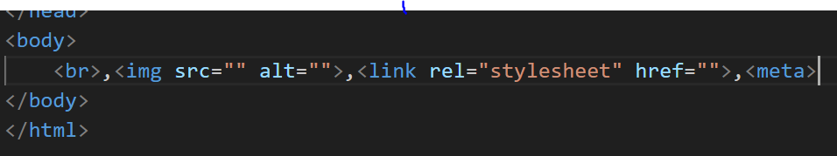

1. What are Html Entities? With Example Html Entities are the reserved characters that are use in the html document. They are not present in your standard keyboard they provide a wide range of characters, allowing you to add icons, geometric shapes.
2. What are different types of list in html? With Example There are three types of list in html they are: OL= Oder List. In Oder list small and capital letter UL= Under List . In under list there are some marks like square circle , disk, non. DL= Data List**/** Description List 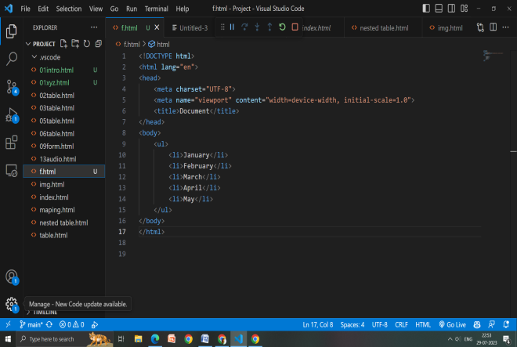 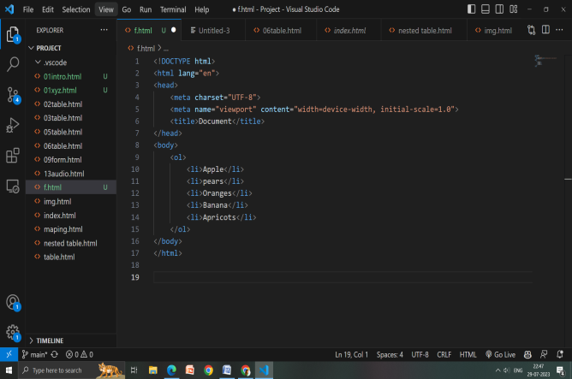 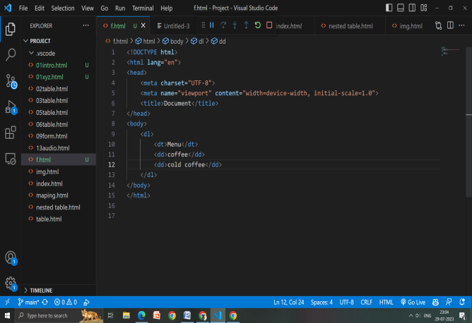
3. What is class attribute in Html? With example. Class attribute mean we can select more than one element and also we can change the style in that by using the class name for example: 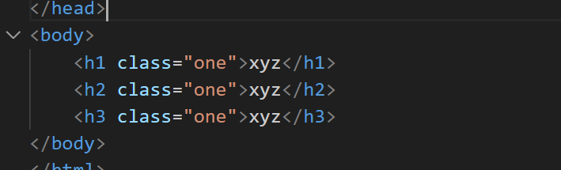
4. What is difference between the ‘id’ attribute and the class attribute of Html element? With example. Class attribute means that we can select one or more then classnames for an element. Id attribute which specifies a unique id for Html. class attribute can use multiple time in html but id attribute can only use for the once in html. For an example: class attribute 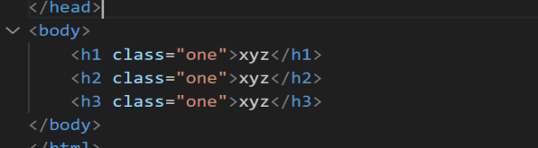 Id attribute: 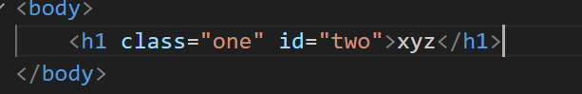
5. What are the various formatting tags in Html? The formatting tags are for designed the various types of text. 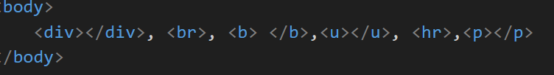 this are the various formatting tags which are been used for designing.
6. How is cell padding is different from cell spacing? With example. Cell padding means to give the inside cell space. It define the space between cell wall and the content. Example: 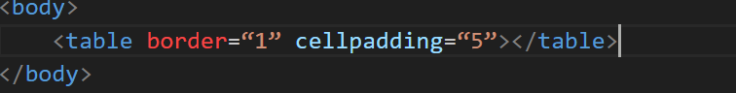 Cell spacing means to give outside cell space. It define the space between each cell. Example: 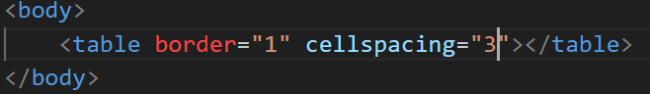
7. How we can club two or more rows and columns into a single row or columns in an html table? With example. To merge the row and columns we have to use a tag cal rowspan and colspan. Rowspan is use to merge the row. Colspan is use for columns Example: 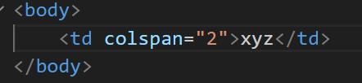

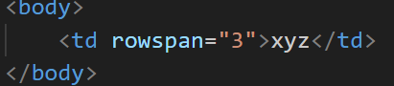

1. What is different between a block-level element and an inline element? An inline element does not start from new line. It only take up as much as width is required. Block level element will cover the 100% width of the page then the other part will go down.
2. How to create a Hyperlink in html? With example. To make a hyperlink in html we have to use <a>and </a> here the **ta**gs start <a> and end </a> this will create the hyperlink in html.

Example: 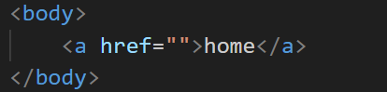

1. What is the use of an iframe tag? Explain with example Iframe tag is use to load the content from another site. Example if we want a to location then there we can use the code iframe here we have to open the location what we can and then we have to the share option and there embad a map from there we can copy the code and paste it and then run. So here we can se the location on the webpage.
2. What is the use of a span tag? Explain with example.

Span tag are used for making a group of inline element. This tag does not take visual change. And span tag is an inline tags.

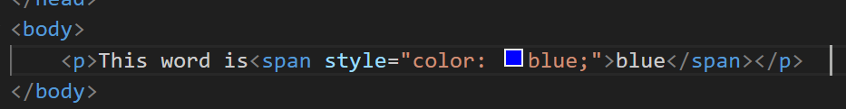

1. How to insert a picture into a background image of a web page?

To insert the background image we can use the attribute in the body tag of the html.

 div {

            height: 300px;

            width: 300px;

            background-image: url(download.jpg);

            background-size: contain;

            background-repeat: no-repeat;

            border: 2px solid black;

            overflow: auto;

        }

1. How active link is different from normal links?

An active link can recognize when we put mouse cursor is placed over that link: others recognize active link when the link has the focus. Those link that don’t have mouse cursor over it is normal link.

1. What are the different tags to separate sections of text?

<br>-tags this tags is used to separate the text from one line to the new line.

<p>-tags this tag use for the paragraph of text.

1. What is SVG?

Scalable vector graphics. Svg has several method for drawing paths, boxes, circles, text, and graphic image.

1. What is different between html and xhtml?

Html stands of hypertext markup language where as xhtml stand of extensible hypertext marks up language both language is used to create the web and android applications.

1. What are logical and physical tags in HTML?

Physical tags: tags that are used to provide the visual appearance to the text.

Logical tags: tags that are used to add some logical or semantic value to the text.